TESTING PROCESS

**Qui Ngo**

**16/05/2017**

**Version 1.0**

**Revision History**

|  |  |  |  |  |  |
| --- | --- | --- | --- | --- | --- |
| **Version** | **Date** | **Author** | **Editor** | **Content** | **Status** |
| 1.0 | 16/05/2016 | Qui Ngo |  | Create Testing Process document | Done |

**Table of Contents**

**1.** **Introduction** 4

**1.1.** **Purpose** 4

**1.2.** **Intended audience** 4

**2.** **Process** 5

**2.1.** **Overview** 5

**2.2.** **Planning** 6

**2.2.1.** **Purpose** 6

**2.2.2.** **Entry & Exit Conditions/Criteria’s** 6

**2.2.3.** **Role and Activities** 6

**2.2.4.** **Tools** 6

**2.2.5.** **Templates** 6

**2.3.** **Analysis and Design Test Case** 6

**2.3.1.** **Purpose** 6

**2.3.2.** **Entry & Exit Conditions/Criteria’s** 6

**2.3.3.** **Role and Activities** 6

**2.3.4.** **Tools** 7

**2.3.5.** **Templates** 7

**2.4.** **Implementation and Execution** 7

**2.4.1.** **Purpose** 7

**2.4.2.** **Entry & Exit Conditions/Criteria’s** 7

**2.4.3.** **Role and Activities** 7

**2.4.4.** **Tools** 7

**2.4.5.** **Templates** 8

**2.5.** **Evaluation Exit Criteria’s and Reporting** 8

**2.5.1.** **Purpose** 8

**2.5.2.** **Entry & Exit Conditions/Criteria’s** 8

**2.5.3.** **Role and Activities** 8

**2.5.4.** **Tools** 8

**2.5.5.** **Templates** 8

**2.6.** **Close Activities** 8

**2.6.1.** **Purpose** 8

**2.6.2.** **Entry & Exit Conditions/Criteria’s** 8

**2.6.3.** **Role and Activities** 9

**2.6.4.** **Tools** 9

**2.6.5.** **Templates** 9

**3.** **References** 9

**List of Figure**

**Figure 1.F-Team Testing Process** 7

**List of Table**

**Table 1. Intended audience** 6

**Table 2. Planning Role and Activities** 8

**Table 3. Analysis and Design Test Case Role and Activities** 8

**Table 4. Implementation and Execution Role and Activities** 9

**Table 5. Evaluation Exit Criteria’s and Reporting** 10

**Table 6. Close Activities Role and Activities** 11

# **Introduction**

## **Purpose**

Testing is a process rather than a single activity. This process starts from test planning then designing test cases, preparing for execution and evaluating status till the test closure.

## **Intended audience**

|  |  |  |
| --- | --- | --- |
| **Role** | **Name** | **Responsibility** |
| Test Leader | Qui Ngo | Develop Test Plan, Test Case and Monitoring in Tet Phase |
| Project Manager | Van Phan | Monitoring and Control Schedule |
| Tester | Nhuan Tran,Tan Huynh, Thang Nguyen | Develop Test Case, Execution Test Case and Develop Test Report. Communication with Develop Team |

**Table 1. Intended audience**

# **Process**

## **Overview**

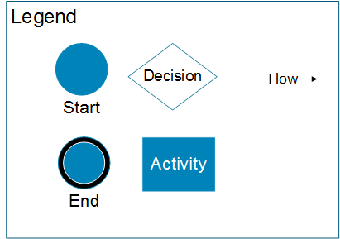

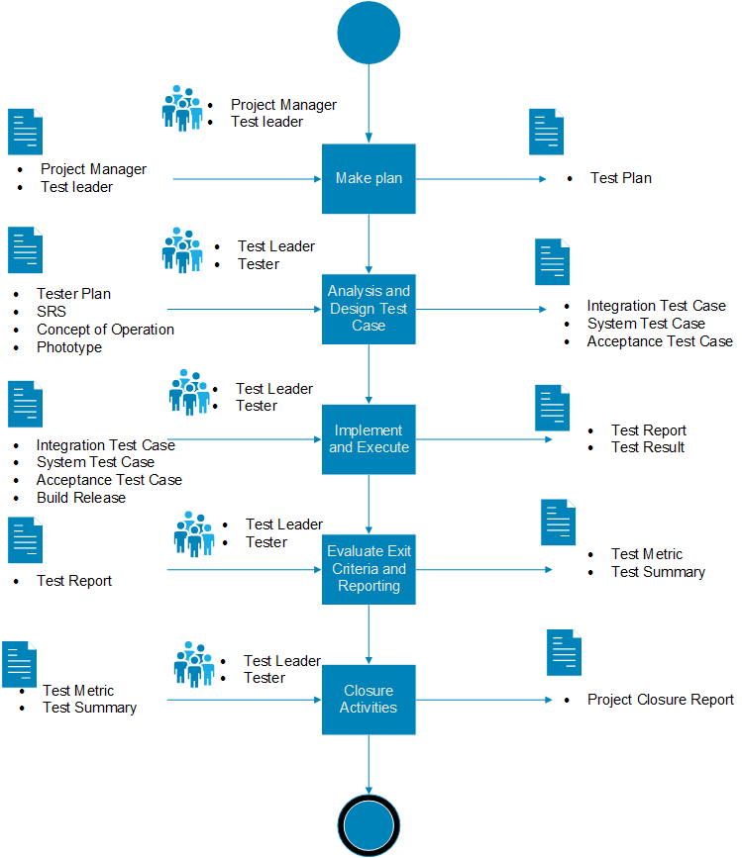

**Figure 1.TripleX Team Testing Process**

## **Planning**

* + 1. **Purpose**

In this step, Test Leader, Will Develop Test Plan, Test Strategy for project.

* + 1. **Entry & Exit Conditions/Criteria’s**

**Entry:**

* Requirement phase completed

**Exit:**

* Test plan and Test Strategy of project completed
  + 1. **Role and Activities**

|  |  |  |  |  |
| --- | --- | --- | --- | --- |
| **Input** | **Role** | **Step** | **Activities** | **Output** |
| * Project Plan | * Test Leader | * Planning | Test Leader will base on Project Plan develop Test Plan and Test Strategy for project | * Test Plan |

**Table 2. Planning Role and Activities**

* + 1. **Tools** 
       - Microsoft word
       - SVN Github
    2. **Templates**
       - ECB_TE_TestPlan_Template

## **Analysis and Design Test Case**

* + 1. **Purpose**

In this step, Test Leader, will base on Requirement Document Baselined analyze and design test case for project.

* + 1. **Entry & Exit Conditions/Criteria’s**

**Entry:**

* + - * Requirement Phase Completed and all Requirement Document Baselined

**Exit:**

* + - * All test case completed
    1. **Role and Activities**

|  |  |  |  |  |
| --- | --- | --- | --- | --- |
| **Input** | **Role** | **Step** | **Activities** | **Output** |
| * Project Plan * SRS * Concept of Operation * Prototype | * Test Leader * Tester | * Analysis and Design Test Case | Test Leader and Tester will base on Project Plan develop Test Case for project | * Integration Test Case * System Test Case * Acceptance Test Case |

**Table 3. Analysis and Design Test Case Role and Activities**

### **Tools**

* Microsoft Excel
* Microsoft Word
* SVN GitHub

### **Templates**

* ECB_TE_IntegrationTestCase_Template
* ECB_TE_SystemTestCase_Template
* ECB_TE_AcceptanceTestCase_Template

## **Implementation and Execution**

### **Purpose**

In this step Tester, will run test case base on build release form develop team

### **Entry & Exit Conditions/Criteria’s**

**Entry:**

* Develop released build

**Exit:**

* All Function in released build tested
  + 1. **Role and Activities**

|  |  |  |  |  |
| --- | --- | --- | --- | --- |
| **Input** | **Role** | **Step** | **Activities** | **Output** |
| * Integration Test Case * System Test Case * Acceptance Test Case * Build Release | * Test Leader * Tester | * Implementation and Execution | Tester execution test and develop test report and confirm with Test Leader  Test Leader will send test report to Develop Team | * Test Report * Test Result |

**Table 4. Implementation and Execution Role and Activities**

### **Tools**

* Microsoft Word
* Microsoft Excel
* SVN GitHub

### **Templates**

* ECB_TE_TestReport_Template

## **Evaluation Exit Criteria’s and Reporting**

### **Purpose**

In this step, Test Leader, will check the test logs against the exit criteria specified in test planning and write a test summary report for stakeholders

### **Entry & Exit Conditions/Criteria’s**

**Entry:**

* Test case have been finished

**Exit:**

* Test Metrix and Summary release to stakeholders
  + 1. **Role and Activities**

|  |  |  |  |  |
| --- | --- | --- | --- | --- |
| **Input** | **Role** | **Step** | **Activities** | **Output** |
| * Test Report * Test Result | * Test Leader * Tester | * Evaluation Exit Criteria’s and Reporting | Test Leader will collect all Test case have been finished and base on test plan develop test Summary and summary report | * Test Metrix * Test Summary |

**Table 5. Evaluation Exit Criteria’s and Reporting**

### **Tools**

* Microsoft Word
* Microsoft Excel
* SVN GitHub

### **Templates**

* ECB_TE_TestSummary_Template
* ECB_TE_TestPlan_Template
* ECB_PM_MeasurementPlan_Template

## **Close Activities**

### **Purpose**

In this step, Test closure activities are done when software is delivered.

### **Entry & Exit Conditions/Criteria’s**

**Entry:**

* Reporting have been completed and send to stakeholders

**Exit:**

* Product acceptance delivery to customer
  + 1. **Role and Activities**

|  |  |  |  |  |
| --- | --- | --- | --- | --- |
| **Input** | **Role** | **Step** | **Activities** | **Output** |
| * Test Metrix * Test Summary | * Test Leader * Tester | * Close Activities | Test Leader check with planned deliverables and to ensure that all incident reports have been resolves. | * Project Closure |

**Table 6. Close Activities Role and Activities**

### **Tools**

* + - * Microsoft Word
      * Microsoft Excel
      * SVN GitHub

### **Templates**

* ECB_PM_Reflection_Template
* ECB_IM_UserGuide_Template
* ECB_IM_GuideLine_Template

# **References**

**http://istqbexamcertification.com/what-is-fundamental-test-process-in-software-testing/**